**20. Using input-output stock-flow consistent models to simulate and assess ‘circular economy’ strategies**

M. Bimpizas-Pinis, A. Genovese, A. Kaltenbrunner, E. Kesidou, B. Purvis, J.B. Ramos Torres Fevereiro, O. Valles Codina, and M. Veronese Passarella

*Abstract*: The Circular Economy (CE) paradigm has gained significant traction in both academic and industrial circles over the past decade. While there is an intuitive association between transitioning to a CE and achieving a more sustainable society, there has been limited scrutiny regarding its economic viability. To address this, macroeconomic tools are needed to assess the impacts of CE policies on society, the economy, and the ecosystem. The field of ecological macroeconomics can meet this need through various promising modelling approaches. This chapter has two main objectives. Firstly, it provides a brief overview of macroeconomic modelling developments that address CE issues, with a focus on the most widely used approaches and tools. Secondly, the chapter argues that combining input-output (IO) analysis with stock-flow consistent (SFC) modelling is one of the most promising methods for simulating, assessing, and comparing CE strategies. To support this argument, the main features of a simplified IO-SFC model for a capitalist economy are presented and discussed. In this model, money is endogenously created, production is demand-driven, and the macro-economy is divided into industries that produce goods and services while generating waste and CO2 emissions. The results demonstrate that restructuring production and consumption patterns to adopt CE-driven practices is insufficient to ensure a transition to a more sustainable economy, as long as production decisions remain driven by private interests.

*Keywords*: Circular Economy, Stock-Flow Consistent Models, Input-Output Analysis, Waste, Carbon Emissions

*Research question statement*: This contribution emphasises the need for macroeconomic tools to assess the impacts of CE policies on society, the economy, and the ecosystem. It highlights the potential of combining input-output analysis with stock-flow consistent modelling for effective simulation and comparison of CE strategies.

# 20.1 Introduction

The concept of Circular Economy (CE) has gained significant traction in both academic and industrial spheres over the past decade. While transitioning towards a CE is intuitively associated with a more sustainable society, there has been limited examination of its economic viability. To address this gap, there is a need for macroeconomic tools that can assess the impacts of CE policies on society, the economy, and the ecosystem. The field of ecological macroeconomics can fulfil this requirement through various promising modelling approaches.

This chapter aims to achieve two objectives. Firstly, it provides a brief overview of the literature on macroeconomic modelling advancements in addressing CE issues, with a focus on the most widely used approaches and tools. Secondly, the chapter argues that combining input-output (IO) analysis with stock-flow consistent (SFC) modelling represents one of the most promising methods to simulate, evaluate, and compare CE strategies. To support this argument, the main features of a simplified IO-SFC model for a multi-regional capitalist economy under different exchange-rate regimes are presented and discussed. In this model, money is endogenously created, production is driven by demand, and the macro-economy is divided into one or two regions and industries that produce goods and services while generating waste and CO2 emissions.

Before a systematic in-depth investigation of many CE scenarios, our preliminary results indicate that restructuring production and consumption patterns to adopt CE-driven practices alone is insufficient to ensure the transition towards a more sustainable economy, as long as production decisions remain driven solely by private interests. For instance, critical industries for the CE transition may employ more men than women and thus reinforce, rather than weaken, the gender income gap. Similarly, CE interventions restricted to the Global North may lead to economic losses, unemployment, or over-extraction of natural resources in the Global South if the core-periphery structure of the international division of labour is neglected. In sum, activist government action is indispensable in planning a just transition to a circular economy, which cannot be left to market forces alone.

# 20.2 IO models for CE analysis: the state of the art

Although the CE has garnered significant attention in scientific literature, a comprehensive systematic review of key contributions on CE practices and strategies, along with their macro-level or societal impact, has not yet been published. Notably, Bimpizas-Pinis et al. (2022) stands out as an important exception, as the authors conducted a systematic analysis utilizing the SCOPUS database. They identified nearly 50 thousand unique articles based on 22 relevant keywords. To focus the literature, they selected papers that explicitly addressed macroeconomic *modelling* and/or provided an ex-post evaluation or ex-ante scenario analysis of CE interventions, along with an assessment of the impact on socio-economic variables such as GDP, employment, prices, costs, profits, and wages.

After this refinement process, a final dataset of 55 relevant studies was compiled. These studies can be categorized into three main groups: (a) IO analysis with exogenous determination of final demand (38 studies), (b) IO models with econometric estimation of the evolution of final demand (4 studies), and (c) Neoclassical models, including CGE models, dynamic stochastic general equilibrium (DSGE) models, and some Integrated Assessment Models (IAMs) (13 studies) (Bimpizas-Pinis et al., 2022).

It is worth noting that this review provides a comprehensive overview of the current literature on macroeconomic *modelling* and its relationship to CE interventions and impacts, making it an important reference for further research in the field.

## 20.2.1 Type I input-output models

Interestingly, the majority of IO-based Circular Economy (CE) publications assume an exogenous determination of final demand, which can be referred to as type I input-output models. IO analysis, pioneered by Leontief (1936, 1941) and discussed by Miller and Blair (2009), is an analytical tool that represents interdependencies among sectors or industries within a national or regional economy. IO tables are compiled by national statistical offices and depict transaction flows in an inter-industry table. An IO table shows the destination of sector-related outputs, which can serve as inputs for other sectors in production or be purchased as final products or services by households, firms, the government, or the foreign sector through consumption, investment, government spending, and exports.

The benchmark Leontief IO model determines the quantity of total output needed to meet each level of final demand based on relative prices and available technology. It enables the calculation of the impacts of fluctuations in final demand and technological changes on total output. The benchmark IO model relies on several fundamental assumptions: (i) constant returns to scale, meaning technical coefficients do not depend on production scale; (ii) fixed proportions of factors of production without substitution possibilities; (iii) use of a single technology per sector and production of a single homogeneous product; (iv) no impact of price changes on final demand (zero price-elasticity of demand); (v) absence of supply constraints on labour, capital, natural resources, and financial constraints.

However, it is possible to combine IO analysis with other modelling frameworks that endogenize final demand explicitly, such as: IO models with econometrically estimated evolution of final demand (type b) and IO models based on neoclassical principles like CGE models (type c). When IO tables are integrated with environmental accounts, such as waste flows, emissions, or material use, EEIO models and WIO tables can be derived. These models allow for the analysis of the impacts of changes in technology and final demand on the broader ecosystem. EEIO analysis combines conventional IO tables (expressed in monetary units) with environmental variables (emissions, waste, extraction, resource depletion) for each sector. These additional variables are typically measured in physical units and included in satellite accounts. WIO explicitly introduces waste treatment sectors (e.g., incineration, landfilling, recycling) in the columns of an IO table. These sectors demand waste generated by productive sectors and final demand as inputs and produce treated waste or recycled materials used as intermediate inputs by productive sectors. Therefore, the IO table is expanded in the rows. It is important to note that the total waste generation per sector is net of recycled waste. Increased recycling reduces the waste generation coefficient in each sector. Recycled materials, demanded as inputs by productive sectors, are represented by positive coefficients in the recycling sector.

This methodology can be applied to various CE interventions, including but not limited to alternative end-of-life strategies for electrical appliances, recycling, landfilling, and simple shredding (Kondo and Nakamura, 2004; Nakamura and Kondo, 2006).

## 20.2.2 Type II input-output models

In type II or macro-econometric input-output (MEIO) models, the level and composition of final demand are not exogenous but determined through econometric equations, with coefficients estimated from observed data. Once the final demands are determined for each sector, total outputs are defined using a standard Leontief IO table, which operates on a quantity basis. MEIO models are categorized as demand-driven models, in contrast to neoclassical CGE, DSGE, and standard IAM approaches, which are supply-side models. MEIO models also econometrically determine labour market variables such as hours worked, employment rate, participation rate, etc. These variables are defined as functions of estimated real output, real wage costs, and other factors. Unlike most CGE models, MEIO models do not assume neoclassical conditions. The economy does not converge to a pre-defined equilibrium level of output, let alone full employment. Perfect rationality and perfect competition are also rejected. Economic agents in MEIO models are assumed to operate in imperfect markets under bounded rationality conditions.

Examples of MEIO models that address environmental issues include E3ME (Cambridge Econometrics 2014), PANTA-RHEI (Meyer et al., 2007, 2012), and GINFORS (Giljum et al., 2008; Distelkamp and Meyers, 2019). Overall, MEIO models tend to be optimistic about the possibility of achieving green economic growth, even when considering rebound effects. It should be noted that the demand-driven nature of these models implies that investment in new technologies associated with CE practices will generally stimulate economic growth, at least during the transition phase. Furthermore, the investigated CE practices in the reviewed papers typically involve high resource efficiency. On closer examination, what is being modelled is an increase in productivity that, coupled with the assumption of fixed mark-ups, influences prices. This, in turn, stimulates final demand both directly (through the price effect) and indirectly (through the income effect). Similarly, increases in recycling are linked to higher expenditures and employment requirements compared to other forms of resource waste management, resulting in higher income and employment multipliers. However, other CE strategies, such as product life extension or functional economy practices, are likely to be less effective in terms of output and employment generation.

# 20.3 SFC models for CE analysis: bridging the gap

SFC models can be considered a specific class of system dynamics tools, primarily developed by post-Keynesian macroeconomists since the early 2000s (Godley and Lavoie, 2006; Caverzasi and Godin, 2015; Nikiforos and Zezza, 2017). In the last decade, SFC models have gained traction in ecological macroeconomics due to their ability to integrate consistently and comprehensively the flows and stocks of the economy and the ecosystem (Carnevali et al., 2019). This feature makes them highly flexible and versatile for simulating, analyzing, and comparing alternative environmental policy scenarios. However, one limitation is that SFC models only consider aggregate output, neglecting the interdependencies between different industries.

Formally, SFC models are dynamical systems of discrete-time difference equations (or occasionally continuous-time differential equations), where accounting identities are coupled with equilibrium conditions and behavioral equations. These behavioral equations are typically based on post-Keynesian principles, including the following: a) economic agents have target stock-flow norms they aim to achieve; b) money is endogenously created by the banking sector; c) supply tends to adjust to demand in the short and long run, rather than the other way around.

In theory, SFC behavioral equations can be based on any theoretical framework. Notably, despite their focus on cost optimality, most CGE models are also stock-flow consistent, although they lack the dynamic aspect. Additionally, unlike SFC models, CGE models usually concentrate on the real economy and exclude the financial sector. While SFC models are often aggregative, they can also be microfounded by deriving the emerging behavior of aggregate variables from the interaction of heterogeneous agents (AB-SFC) (Caiani et al., 2016) or mesofounded by explicitly considering the IO structure of the production sector (IO-SFC) (Berg et al., 2015).

SFC analysis is particularly well-suited to capture the dynamic interactions between the economy and the environment (Dafermos et al., 2017, 2018), as similar theoretical models are already widespread in the natural sciences in the form of system dynamics models. SFC models offer a promising alternative to standard neoclassical tools (such as CGE models) for analyzing the institutional interaction between the economy and the ecosystem. However, there have been few applications of such models to test and compare CE practices, with exceptions being Veronese Passarella (2022) and Genovese et al. (2023). One reason for this is that standard SFC models only consider aggregate output and overlook the vertical interdependencies between different industries.

Nevertheless, some hybrid IO-SFC models have been developed in recent years (Berg et al., 2015; Valdecantos and Valentini, 2017) that can be used to model the transition towards a CE system. The remainder of this chapter is based on the prototype IO-SFC model developed by Veronese Passarella (2022) and Genovese et al. (2023), which is used to test a simple CE experiment in a single-country economy and a two-country or two-area economy, respectively.

# 20.4 Main features of the model

Although IO-SFC models are still uncommon in macroeconomics and ecological economics, progress has been made in recent years. Veronese Passarella (2022) and Genovese et al. (2023) have transformed a standard aggregative SFC model (based on Godley and Lavoie, 2007) into meso-founded models that incorporate the endogenous creation of both fiat money and bank money. These models also feature market prices adjusting to Sraffa-like reproduction prices, and they disaggregate the economy both vertically (social sectors) and horizontally (production industries). Both models share the same theoretical assumptions and analytical structure. The main difference is that Veronese Passarella (2022) focuses on the impact of CE innovations on the domestic economy, while Genovese et al. (2023) extend the analysis to a two-area economy, explicitly considering the effects of cross-border trade and portfolio investment. In this section, we discuss the key findings associated with a CE innovation in a single-country model and then examine its implications for a multi-country economy.

Each national economy considered consists of five domestic macroeconomic sectors: a) households (which are further divided into wage earners and rentiers); b) private production firms; c) the government sector; d) commercial banks; and e) the central bank. The single-country model also includes a stylized foreign sector, which tracks trade and financial flows with the rest of the world. In the two-area model, each country shares the same institutional structure, and there are no barriers to trade or restrictions on capital flows. Households receive both labour incomes (wages) and capital incomes (profits and interest payments) and purchase consumption goods based on their disposable income and net wealth. Household savings consist of cash (currency), bank deposits, and government bills. The baseline scenario involves three industries (manufacturing, agriculture, and services) where firms produce three outputs (and waste) using the same products as inputs. For simplicity, real supplies always adjust to real demands, and firms do not hold inventories. However, firms accumulate fixed capital and finance their production plans through bank loans. As mentioned, corporate incomes are entirely distributed to households. Bank deposits are created as long as banks grant loans to firms and/or upon demand, while cash is issued by the central bank when the government sector runs budget deficits and/or commercial banks obtain advances.

Both models are coded and simulated in an R environment. Model parameters and exogenous variables have been selected to approximate the baseline scenario discussed by Vallès Codina and Fevereiro (2022). Initial values for endogenous variables are set to zero, and simultaneous solutions for endogenous variables have been obtained through 100 iterations per period. The economy is set in motion by an initial expenditure from the government sector. Private firms produce goods and services based on demand, leading to an increase in output, disposable income, consumption, investment, and imports (and exports). The economy experiences growth following the initial shock and eventually stabilizes at a new steady state, where private consumption equals disposable income and the stock of net wealth remains unchanged (ensuring that households achieve their target wealth-to-income ratio). Economic activity results in the production of waste and CO2 emissions. The models also consider its impact on the functional distribution of income and gender segregation in the labour market, accounting for variations in the share of female workers across industries (assuming that the female labour force is uniformly distributed across industries in both the baseline scenario and the experiments discussed here).

Tables 1 and 2 depict the balance sheets of the single-country model and the two-area model, respectively. Tables 3 and 4 present the corresponding transaction-flow matrices. Figure 1 and Figure 2 illustrate cross-sector (and cross-area) payments and their effects on financial stocks, confirming the integrity of the models (where every payment originates from somewhere and goes to somewhere, and any changes in financial assets/liabilities of one sector are matched by opposite changes in financial assets/liabilities of other sectors). Lastly, tables 5 and 6 and figure 3 display the input-output matrix of each domestic economy and the flows of inputs across industries in the single-country model.

# 20.5 CE innovations in IO-SFC models: preliminary findings

The term ‘circular economy’ (CE) refers to a set of policies and practices aimed at reusing, repairing, sharing, and recycling products and resources to establish a closed-loop system, thereby minimizing waste, pollution, and CO2 emissions (Bimpizas-Pinis et al., 2021). One way to introduce a CE innovation in the aforementioned model is to consider a domestic economy with four industries. The first three industries produce goods and provide services (e.g., manufacturing goods, agricultural goods, and administrative services), while the fourth industry focuses on waste recycling. Specifically, a CE innovation involves changes in the matrix of technical coefficients, resulting in the following:

* Reduction in the quantities of manufacturing and agricultural products and services used as inputs within the same industries.
* Incorporation of recycled waste into the production processes of manufacturing and agricultural goods and the provision of services.
* Utilization of manufacturing and agricultural products and services as inputs in the waste recycling industry.

Regarding the source of the shock, the model assumes that technical change (i.e., the new or target coefficients) is influenced by policy makers. Additionally, the average speed at which technical coefficients converge to their target values is defined as a linear, positive function of government expenditures (as discussed in Veronese Passarella, 2022). In the following subsections, we will explore the implications of CE-oriented government spending in a single-country model and a two-area model, considering two different exchange rate regimes.

## 20.5.1 Single-country model

Figure 4 illustrates the impact of a CE innovation, triggered by increased government spending, on relative prices. Specifically, the adoption of new production techniques creates a fresh market for ‘recycled waste’, leading to a gradual increase in its unit price over time. In contrast, prices of other products and services decline. As expected, the combination of higher government spending and lower consumer goods prices results in an increase in real disposable income and consumption.

The improved production efficiency achieved using recycled waste as an intermediate good reduces the demand for traditional inputs such as manufacturing and agricultural products, as well as services. However, CO2 emissions initially increase due to the overall increase in output, including recycled waste. Nevertheless, the use of more efficient techniques and the lower energy intensity assumed in waste recycling eventually lead to a reduction in emissions compared to the baseline scenario, particularly in the long run when the net product stabilizes and total output even declines. In our preliminary experiment, the temporary nature of the rebound effect is specific to the chosen parameter values. Additional experiments demonstrate that the increase in CO2 emissions can be long-lasting (for a comprehensive discussion on rebound effects, refer to Zink and Geyer, 2017; and Bimpizas-Pinis et al., 2021).

Shifting focus to social variables, Figure 5 reveals that, all else being equal, the functional income distribution becomes more favourable to workers due to two opposing effects coming into play. On one hand, the higher stock of government debt leads to increased interest payments to rentiers, which influences the wage share of total income. On the other hand, the recycling industry is assumed more labour-intensive than traditional industries, and this effect prevails. Gender income inequality, however, remains unchanged, although female employment increases in absolute terms. Once again, this outcome is driven by the higher labour intensity of the new recycling industry. Income inequality in terms of class and gender would increase in the case the new recycling industry had a lower labour intensity and a lower share in female employment.

## 20.5.2 Two-area model with fixed exchange rate

Figure 5 illustrates the impact of a CE innovation triggered by increased government spending on selected variables in a 2-area economy model. The innovation only takes place in Area 1, and the currency exchange rate between the two areas is fixed: this scenario is critical as it applies to single-currency areas with regional economic diversity, such as the European Union, or the EU or the US with countries that maintain a fixed peg with the euro or the US dollar, such as Western Africa (e.g. the Financial Community of Africa, CFA) or China, Lebanon, Argentina, and Ecuador (which can also be considered as semi-floating in the next section). Despite the increase in government spending (quadrant (a)), the import of Area 1 falls sharply (quadrant (b)) due to the decline in the demand for (foreign) inputs due to the CE decrease in input requirements in production (quadrant (e)) and the trade balance becomes positive (quadrant (b)). The economy grows, and so does female employment, following total employment (quadrant (f)). The stock of accumulated waste reduces due to both recycling and the higher efficiency of domestic production processes (quadrant (g)). Despite the higher ecological efficiency, industrial CO2 emissions peak in the short run, although they fall below the initial level in the medium run (quadrant (h)). The same goes for CO2 concentration in the atmosphere (quadrant (i)).

## 20.5.3 Two-area model with (semi) floating exchange rate

Figure 6 illustrates the impact of a CE innovation in Area 1 when the currency exchange rate between the two areas is free to adjust based on cross-country trade and capital flows (semi-floating exchange rate regime). The main difference compared to the previous case is that, this time, the initial fall in imports (e.g. an improvement in the trade balance) leads to an appreciation of Area 1’s currency (quadrant (d)) and a slight decrease in economic output (i.e. GDP). This new effect, in turn, affects exports negatively, so that the net trade balance actually becomes negative (quadrant (b)) despite the reduction in the demand for inputs from Area 2. Some minor differences in contrast to the fixed exchange-rate regime occur on both ecological and social variables: employment, waste, and emissions all grow less than they would have under a fixed exchange rate regime, due to the negative impact of currency appreciation on the trade balance and, consequently, the output of Area 1. It should be noted that this also implies a larger share of world production taking place in Area 2, the area that has not introduced any CE innovation. While this paradoxical effect is negligible in this simple example, it may have relevant implications when considering a more complex scenario (Carnevali et al., 2020). At this stage, the scenarios investigated are substantially stylized, so that the actual size of each effect will become clear when empirically calibrated with their actual values.

# 20.6 Final remarks

The CE paradigm has gained momentum in both academic and industrial circles in the last decade. Despite the intuitive association of a transition towards a CE with a more sustainable society, there has been limited scrutiny about its economic viability. To address this, there is a need for macroeconomic tools to assess the impacts of CE policies on society, the economy, and the ecosystem. The field of ecological macroeconomics can fulfil this need through various promising modelling approaches. The aim of this chapter was twofold. Firstly, it provided a short overview of macroeconomic modelling developments addressing CE issues, focusing on the most widely used approaches and tools. Secondly, we argued that the combination of IO analysis with SFC modelling is one of the most promising methods to simulate, assess, and compare CE strategies. In order to support this, the main features of three IO-SFC models for a capitalist economy were presented and discussed. Unlike standard SFC models, the proposed models allow dealing with cross-industry interdependencies. Unlike traditional IO models, they allow endogenising technical innovations, by linking the changes in technical coefficients with other variables – such as policy decisions, the evolution of demand conditions, portfolio decisions, and the change in the ecosystem. As a result, a variety of feedback effects can be explicitly modelled. The simple exercises proposed here confirmed that the transition towards a CE system could not rely on higher production efficiency only, due to rebound effects. Its impact on social variables is also ambiguous, as it depends on several factors (such as foreign trade and financial flows), some of which are not under the direct control of the policy makers in a market economy.

# References

Berg, M., Hartley, B., & Richters, O. (2015). A stock-flow consistent input–output model with applicationsto energy price shocks, interest rates, and heat emissions. New journal of physics, 17 (1), 015011.

Bimpizas-Pinis, M., Bozhinovska, E., Genovese, A., Lowe, B., Pansera, M., Alberich, J.P. and Ramezankhani, M.J. (2021). Is efficiency enough for circular economy?. Resources, Conservation & Recycling, 167: 105399.

Bimpizas-Pinis, M., Genovese, A., Purvis, B., Ramos Torres Fevereiro, J.B., Valles Codina, O., and Veronese Passarella, M. (2022). Macroeconomic Models for Assessing the Transition towards a Circular Economy: A Review. JUST2CE Working Paper.

Caiani, A., Godin, A., Caverzasi, E., Gallegati, M., Kinsella, S., & Stiglitz, J. E. (2016). Agent based-stock-flow consistent macroeconomics: Towards a benchmark model. Journal of Economic Dynamics and Control, 69, 375-408.

Cambridge Econometrics (2014). E3ME technical manual, version 6.0. Cambridge Econometrics, Cambridge, UK, 3 (5).

Carnevali, E., Deleidi, M., Pariboni, R., and Passarella, M. V. (2020). Cross-border financial flows and global warming in a two-area ecological SFC model, Socio-Economic Planning Sciences, 75.

Carnevali, E., Deleidi, M., Pariboni, R., and Passarella, M. V. (2019). Stock-flow consistent dynamic models: Features, limitations and developments. Frontiers of heterodox macroeconomics (pp. 223-276). Springer.

Caverzasi, E., & Godin, A. (2015). Post-Keynesian stock-flow-consistent modelling: A survey. Cambridge Journal of Economics, 39 (1), 157-187.

Codina, O. V. and Ramos Torres Fevereiro, J. B. (2022). Macroeconomic Scenario Exploration. Cheat Sheet: Representation of the economy via Input-Output tables. Working paper presented at JUST2CE Consortium Meeting, Thessaloniki, 1 July 2022.

Dafermos, Y., Nikolaidi, M., and Galanis, G. (2017). A stock-flow-fund ecological macroeconomic model. Ecological Economics, 131, 191-207.

Dafermos, Y., Nikolaidi, M., and Galanis, G. (2018). Climate change, financial stability and monetary policy. Ecological Economics, 152, 219-234.

Distelkamp, M., and Meyer, M. (2019). Pathways to a resource-efficient and low-carbon Europe. Ecological Economics, 155, 88–104.

Genovese, A. Ramos Torres Fevereiro, J.B., Vallès Codina, O., and Veronese Passarella, M. (2023) Circular economy innovations in a 2-area input-output stock-flow consistent dynamic model, working paper.

Godley, W. and Lavoie, M. (2007). Monetary economics: an integrated approach to credit, money, income, production and wealth. Springer.

Giljum, S., Behrens, A., Hinterberger, F., Lutz, C., and Meyer, B. (2008). Modelling scenarios towards a sustainable use of natural resources in europe. Environmental Science & Policy, 11 (3), 204/216.

Kondo, Y., and Nakamura, S. (2004). Evaluating alternative life-cycle strategies for electrical appliances by the waste input-output model. The International Journal of Life Cycle Assessment, 9 (4), 236/246.

Leontief, W. (1936). Quantitative input and output relations in the economic systems of the United States. The review of economic statistics, 105–125.

Leontief, W. (1941). The structure of American economy, 1919-1929. An empirical application of equilibrium analysis. Harvard University Press.

Meyer, B., Distelkamp, M., and Wolter, M. I. (2007). Material efficiency and economic-environmental sustainability. Results of simulations for Germany with the model Panta Rhei. Ecological Economics, 63 (1), 192-200.

Meyer, B., Meyer, M., and Distelkamp, M. (2012). Modeling green growth and resource efficiency: New results. Mineral Economics, 24 (2), 145-154.

Miller, R. E., and Blair, P. D. (2009). Input-output analysis: Foundations and extensions. Cambridge University Press.

Nakamura, S., and Kondo, Y. (2006). A waste input-output life-cycle cost analysis of the recycling of end-of-life electrical home appliances. Ecological Economics, 57 (3), 494-506.

Nikiforos, M., and Zezza, G. (2017). Stock-flow consistent macroeconomic models: A survey. Journal of Economic Surveys, 31 (5), 1204-1239.

Valdecantos, S., and Valentini, F. (2017). Understanding and forecasting macroeconomic dynamics of Argentina: An stock-flow consistent input-output model. Working paper.

Veronese Passarella, M. (2022). Circular economy innovations in a simple input-output stock-flow consistent dynamic model. Working paper presented at FMM Conference, 2022.

# Tables and figures

Table 1. Balance sheet in period t = 20, single-country model, baseline scenario



Table 2. Balance sheet in period t = 20, two-area model, baseline scenario

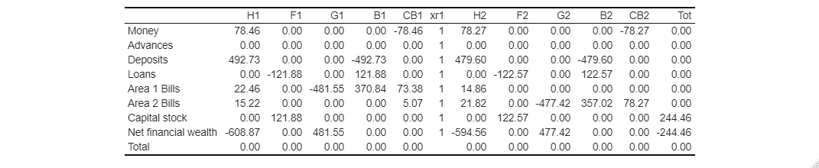

Table 3. Transactions-flow matrix in period t = 20, single-country model, baseline scenario

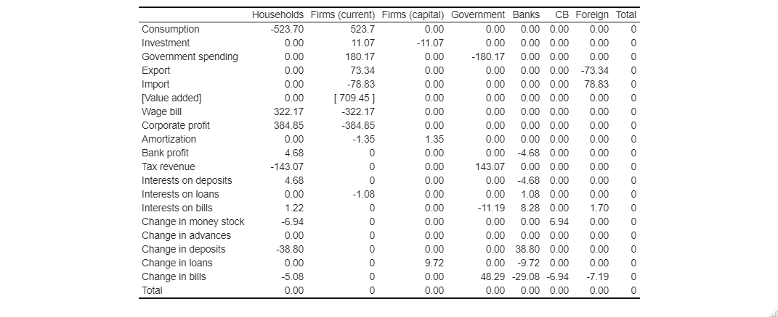

Table 4. Transactions-flow matrix in period t = 20, two-area model, baseline scenario

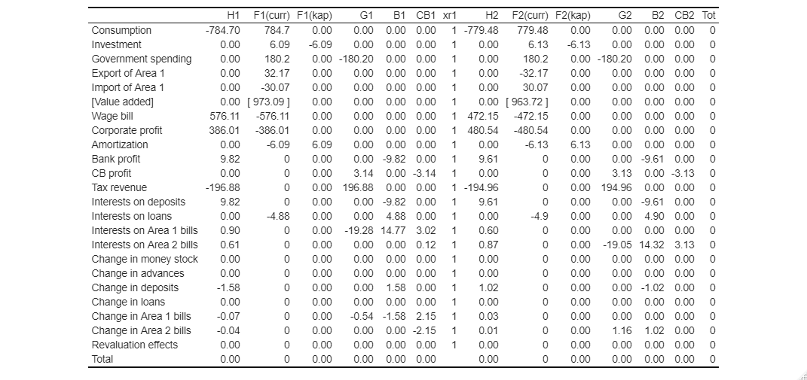

Notes: H = households; F = private firms; G = government; B = banks and financial intermediaries; CB = central bank; xr1 = exchange rate; 1 = Area 1; 2 = Area 2.

Table 5. Input-output matrix in period t = 20, single-country model, baseline scenario

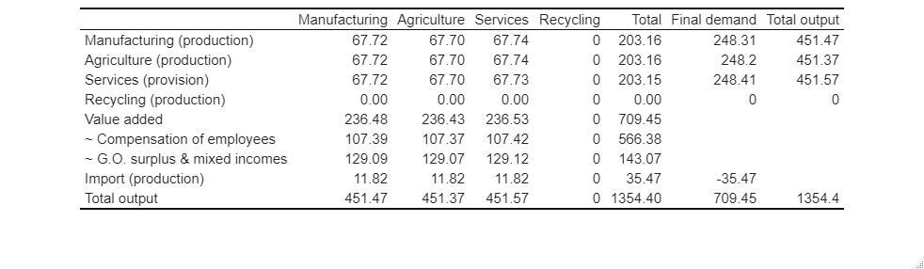

Table 6. Extended input-output matrix in period t = 20, single-country model, baseline scenario



Figure 1. Sankey diagram of cross-sector transactions and changes in stocks in t = 20, single-country model

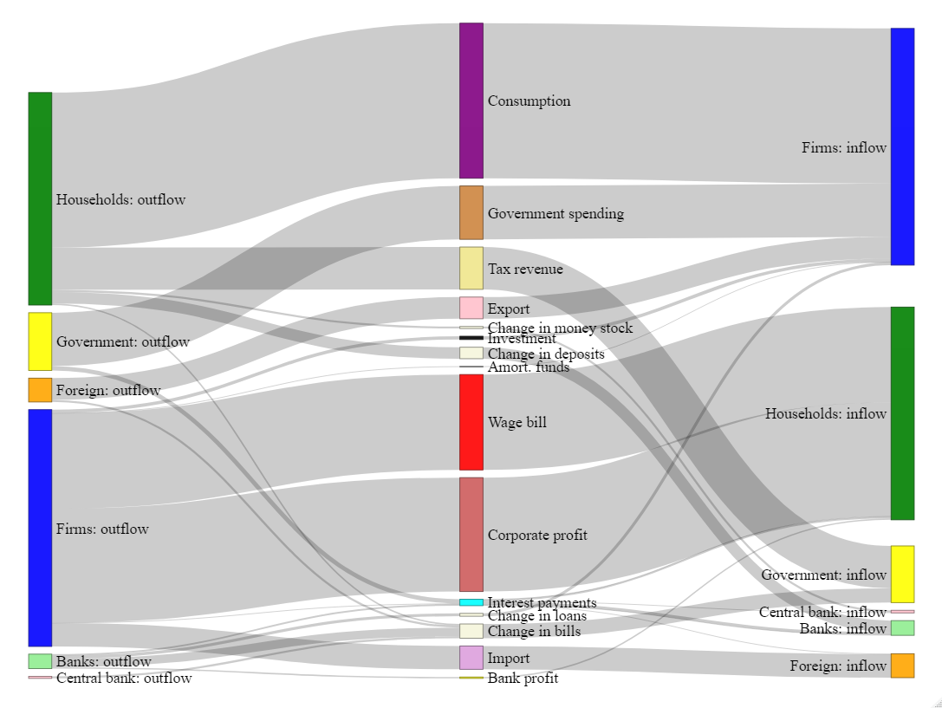

Figure 2. Sankey diagram of cross-sector transactions and changes in stocks in t = 20, two-area model

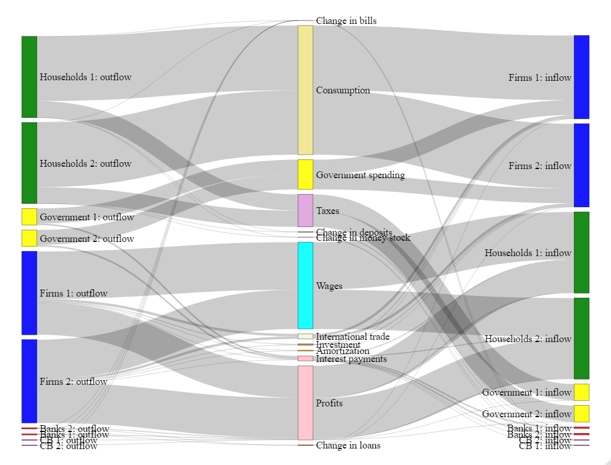

Figure 3. Sankey diagram of cross-industry input-output interdependencies in after CE innovation, single-country model

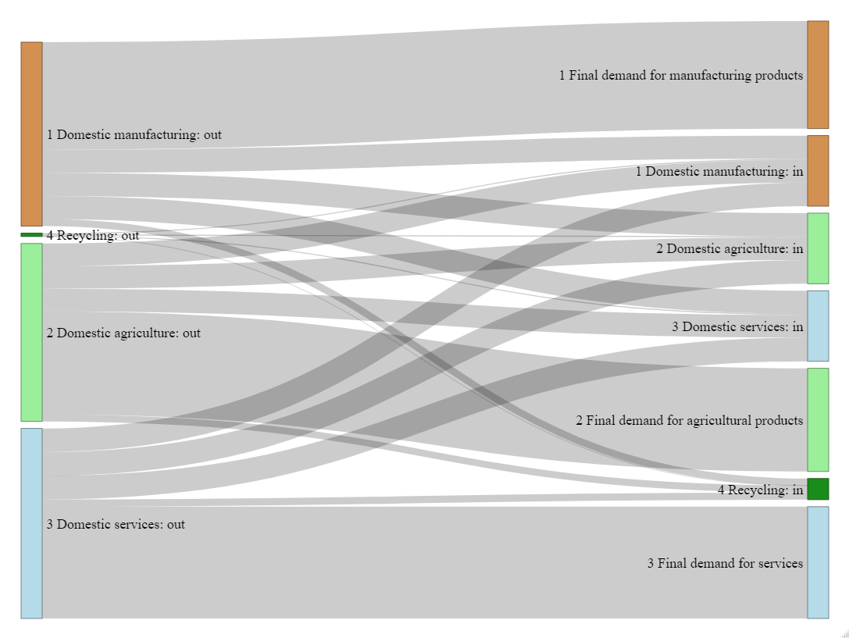

Figure 4. Selected variables after CE innovation, single-country model

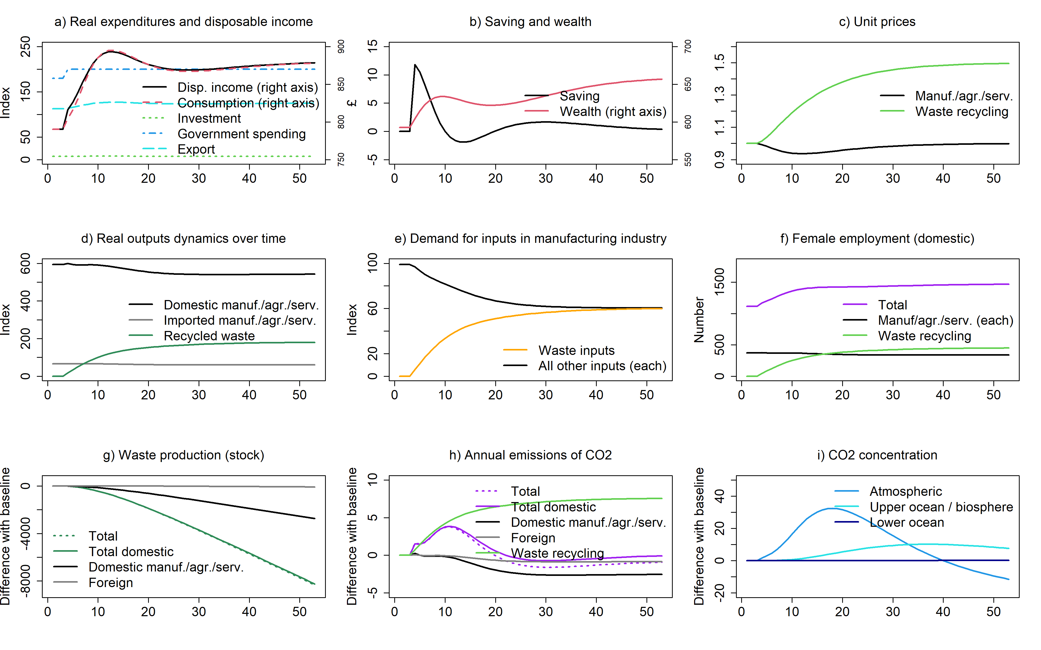

Figure 5. Selected variables after CE innovation, two-area model, fixed exchange rate

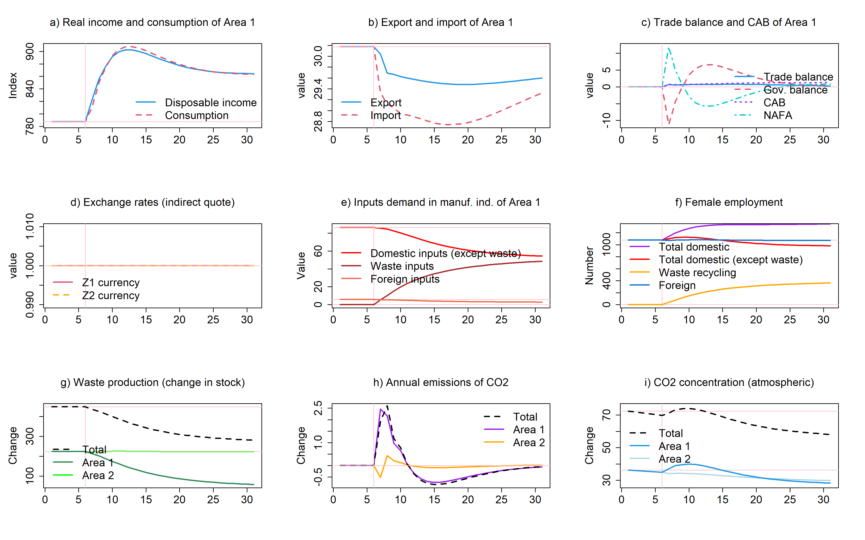

Figure 6. Selected variables after CE innovation, two-area model, floating exchange rate

